1. Логин

id="email"

name="email"

class="co-input-field js-input-field"

Пароль

name="password"

id="password"

class="co-input-field js-input-field"

Кнопка «Войти»

name="commit"

class="co-button co-form-button js-co-login-submit"

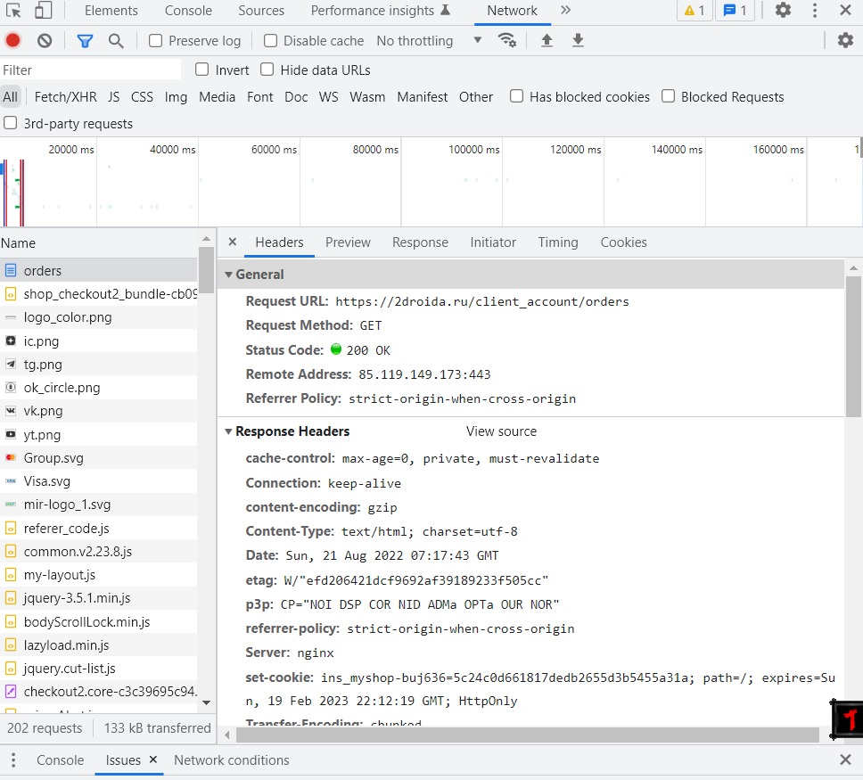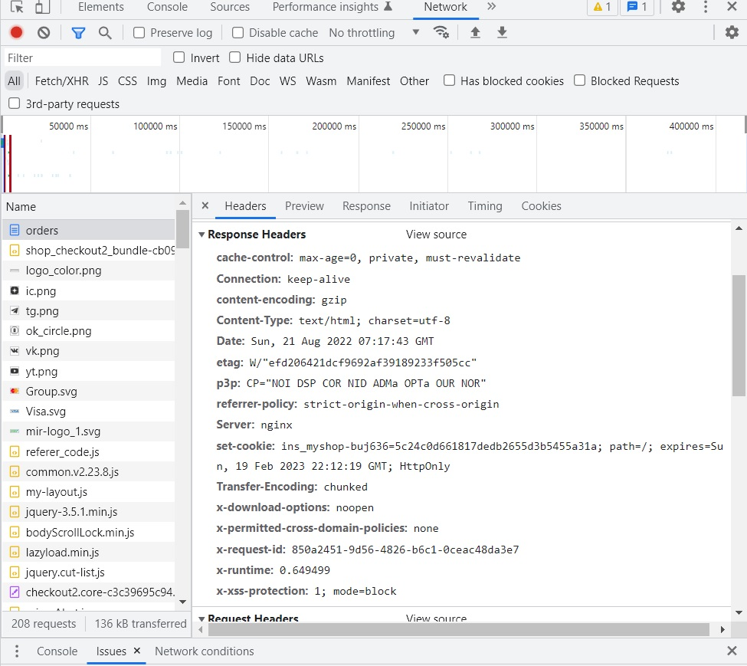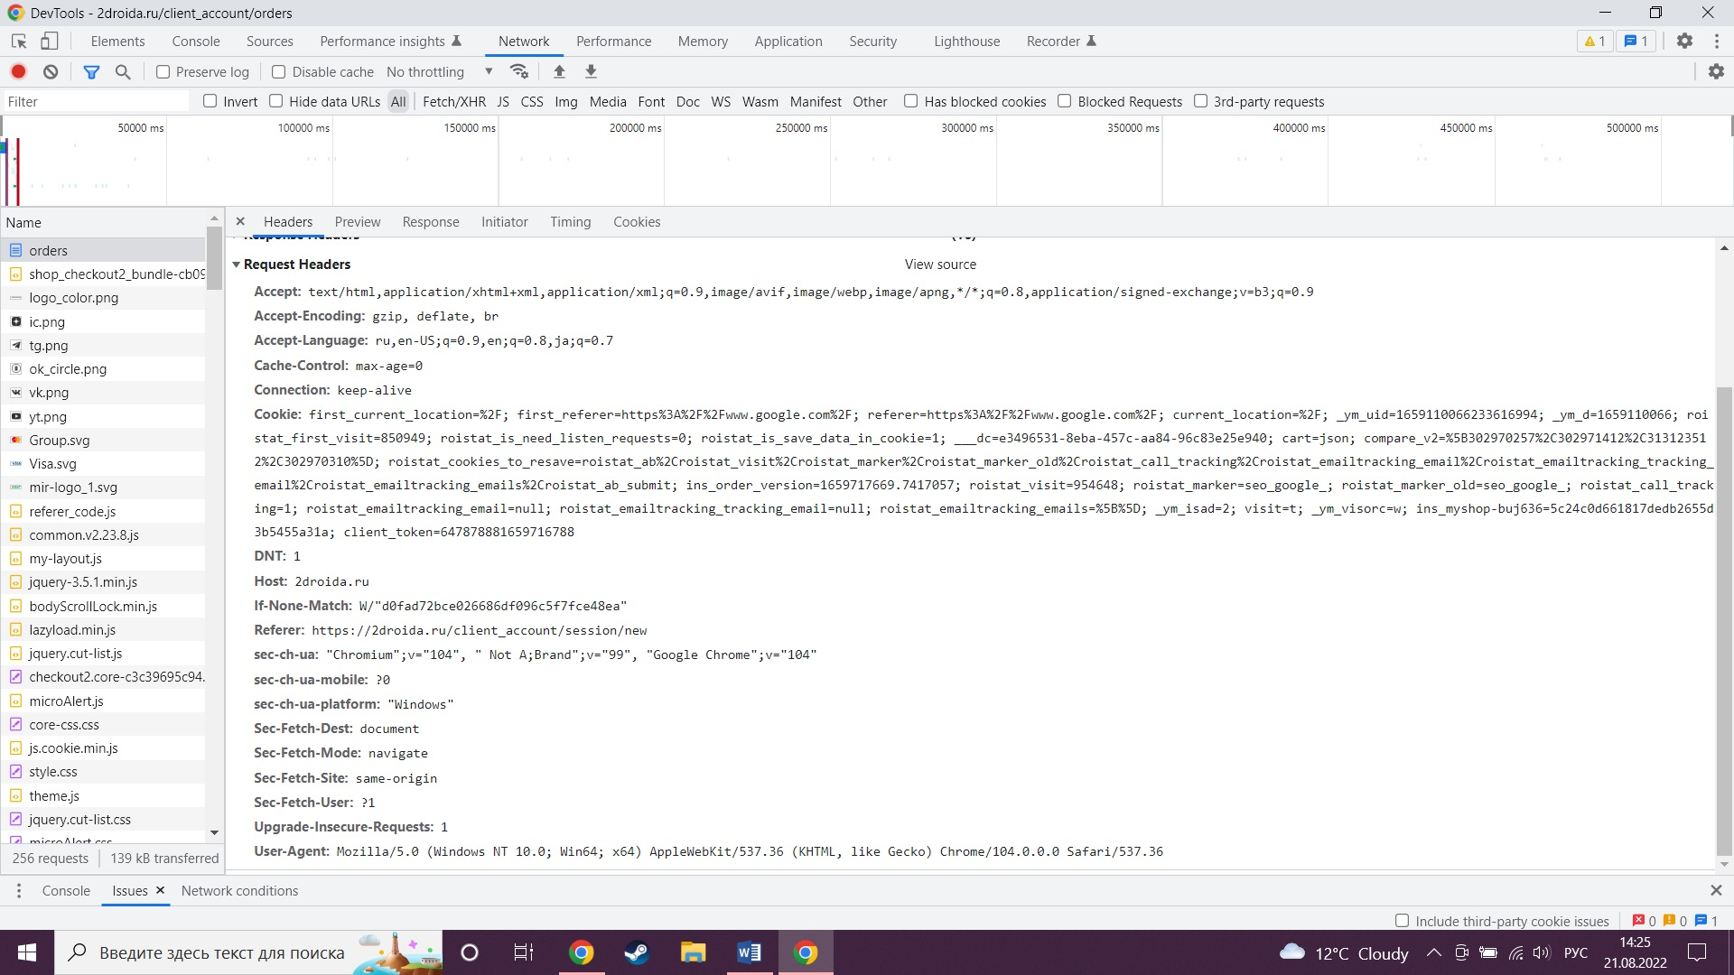

Request URL: <https://2droida.ru/client_account/orders>

User-Agent: Mozilla/5.0 (Windows NT 10.0; Win64; x64) AppleWebKit/537.36 (KHTML, like Gecko) Chrome/104.0.0.0 Safari/537.36

1. Placeholder

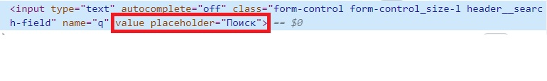



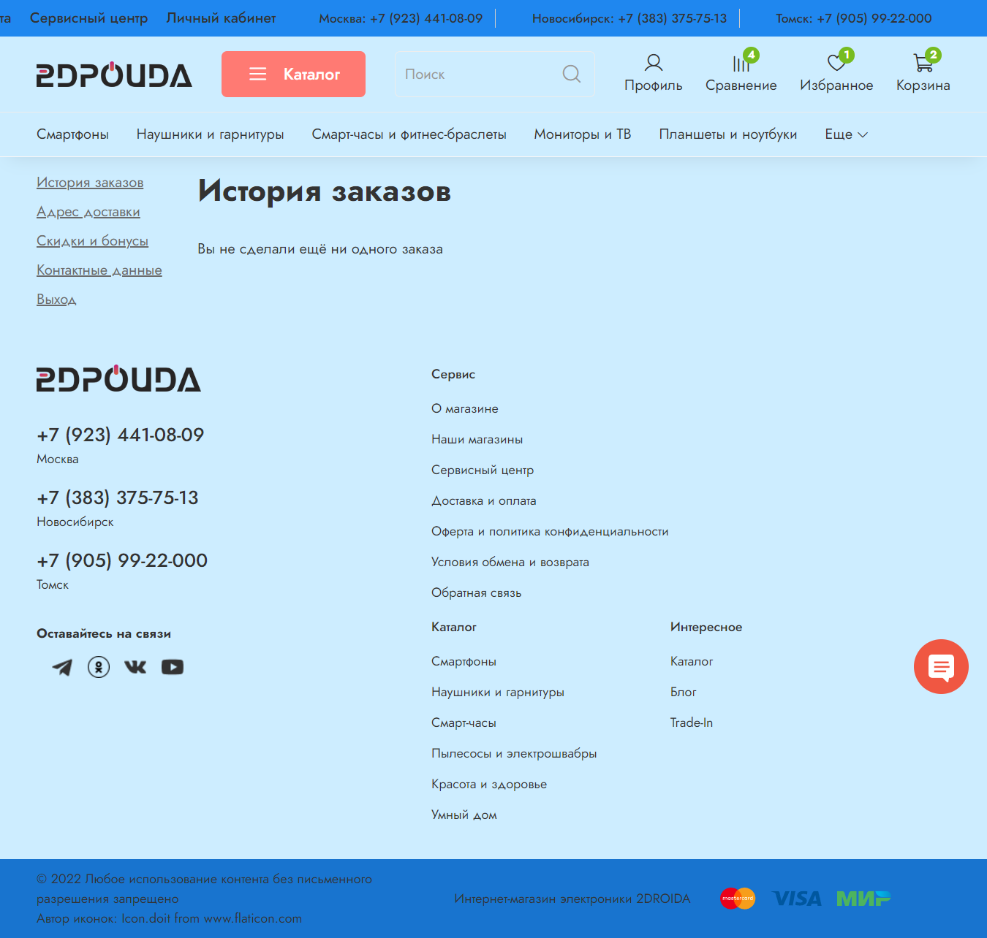



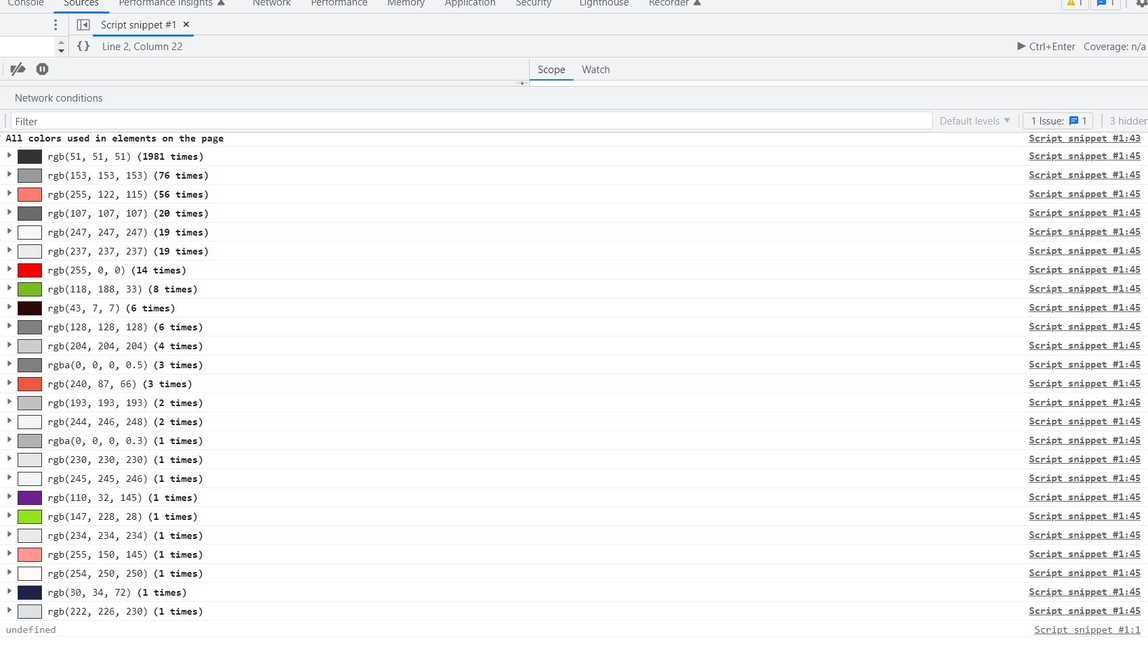

1. Galaxy fold

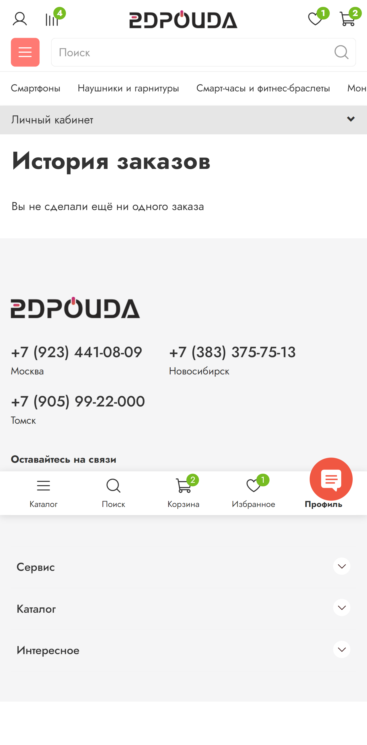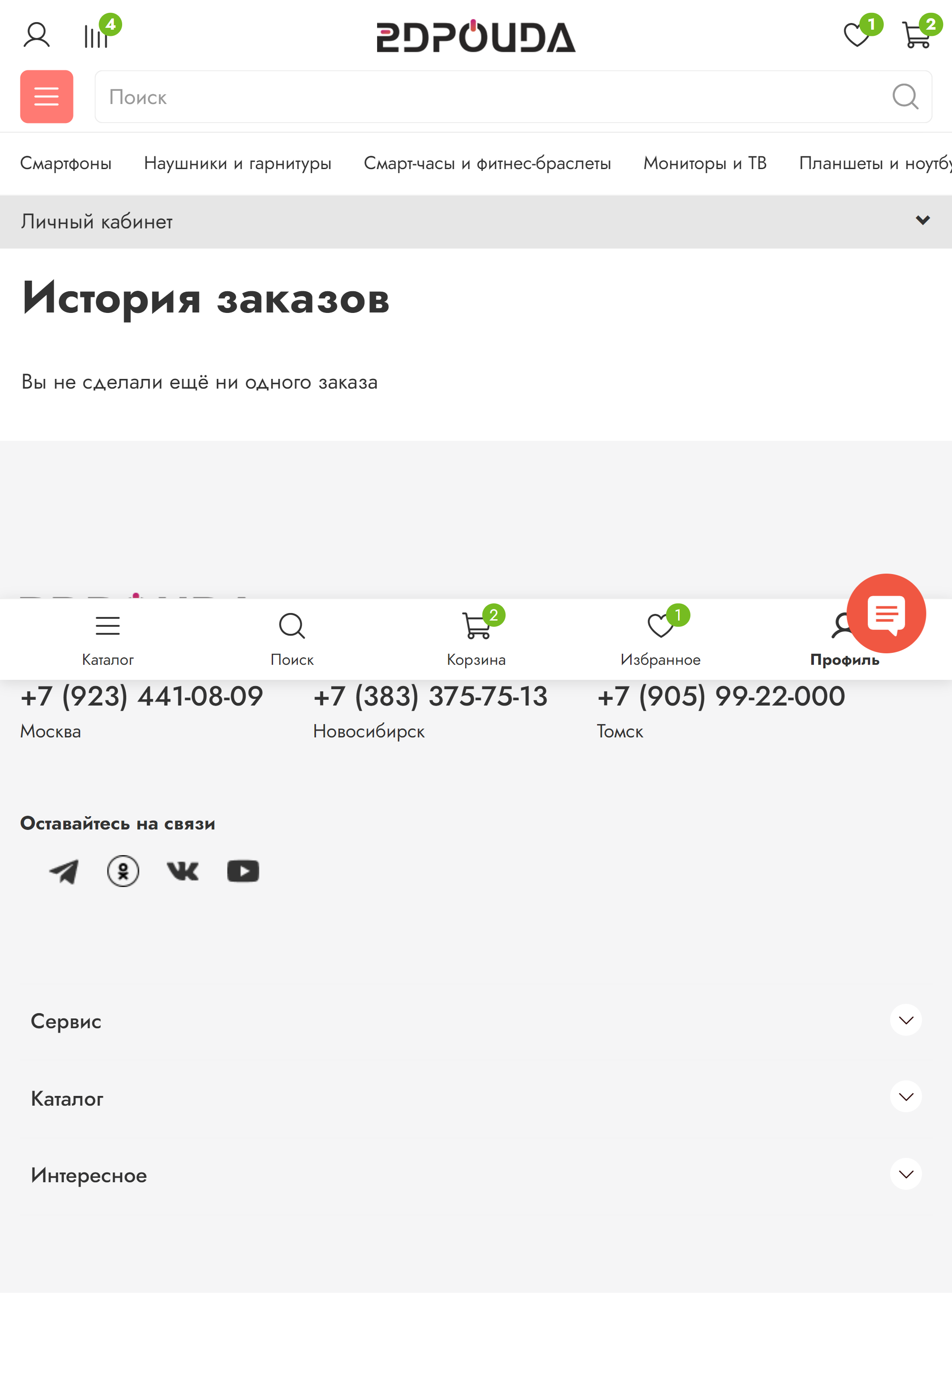

Moto g4

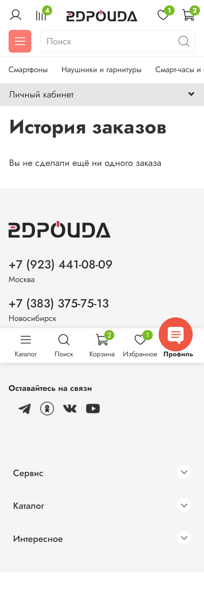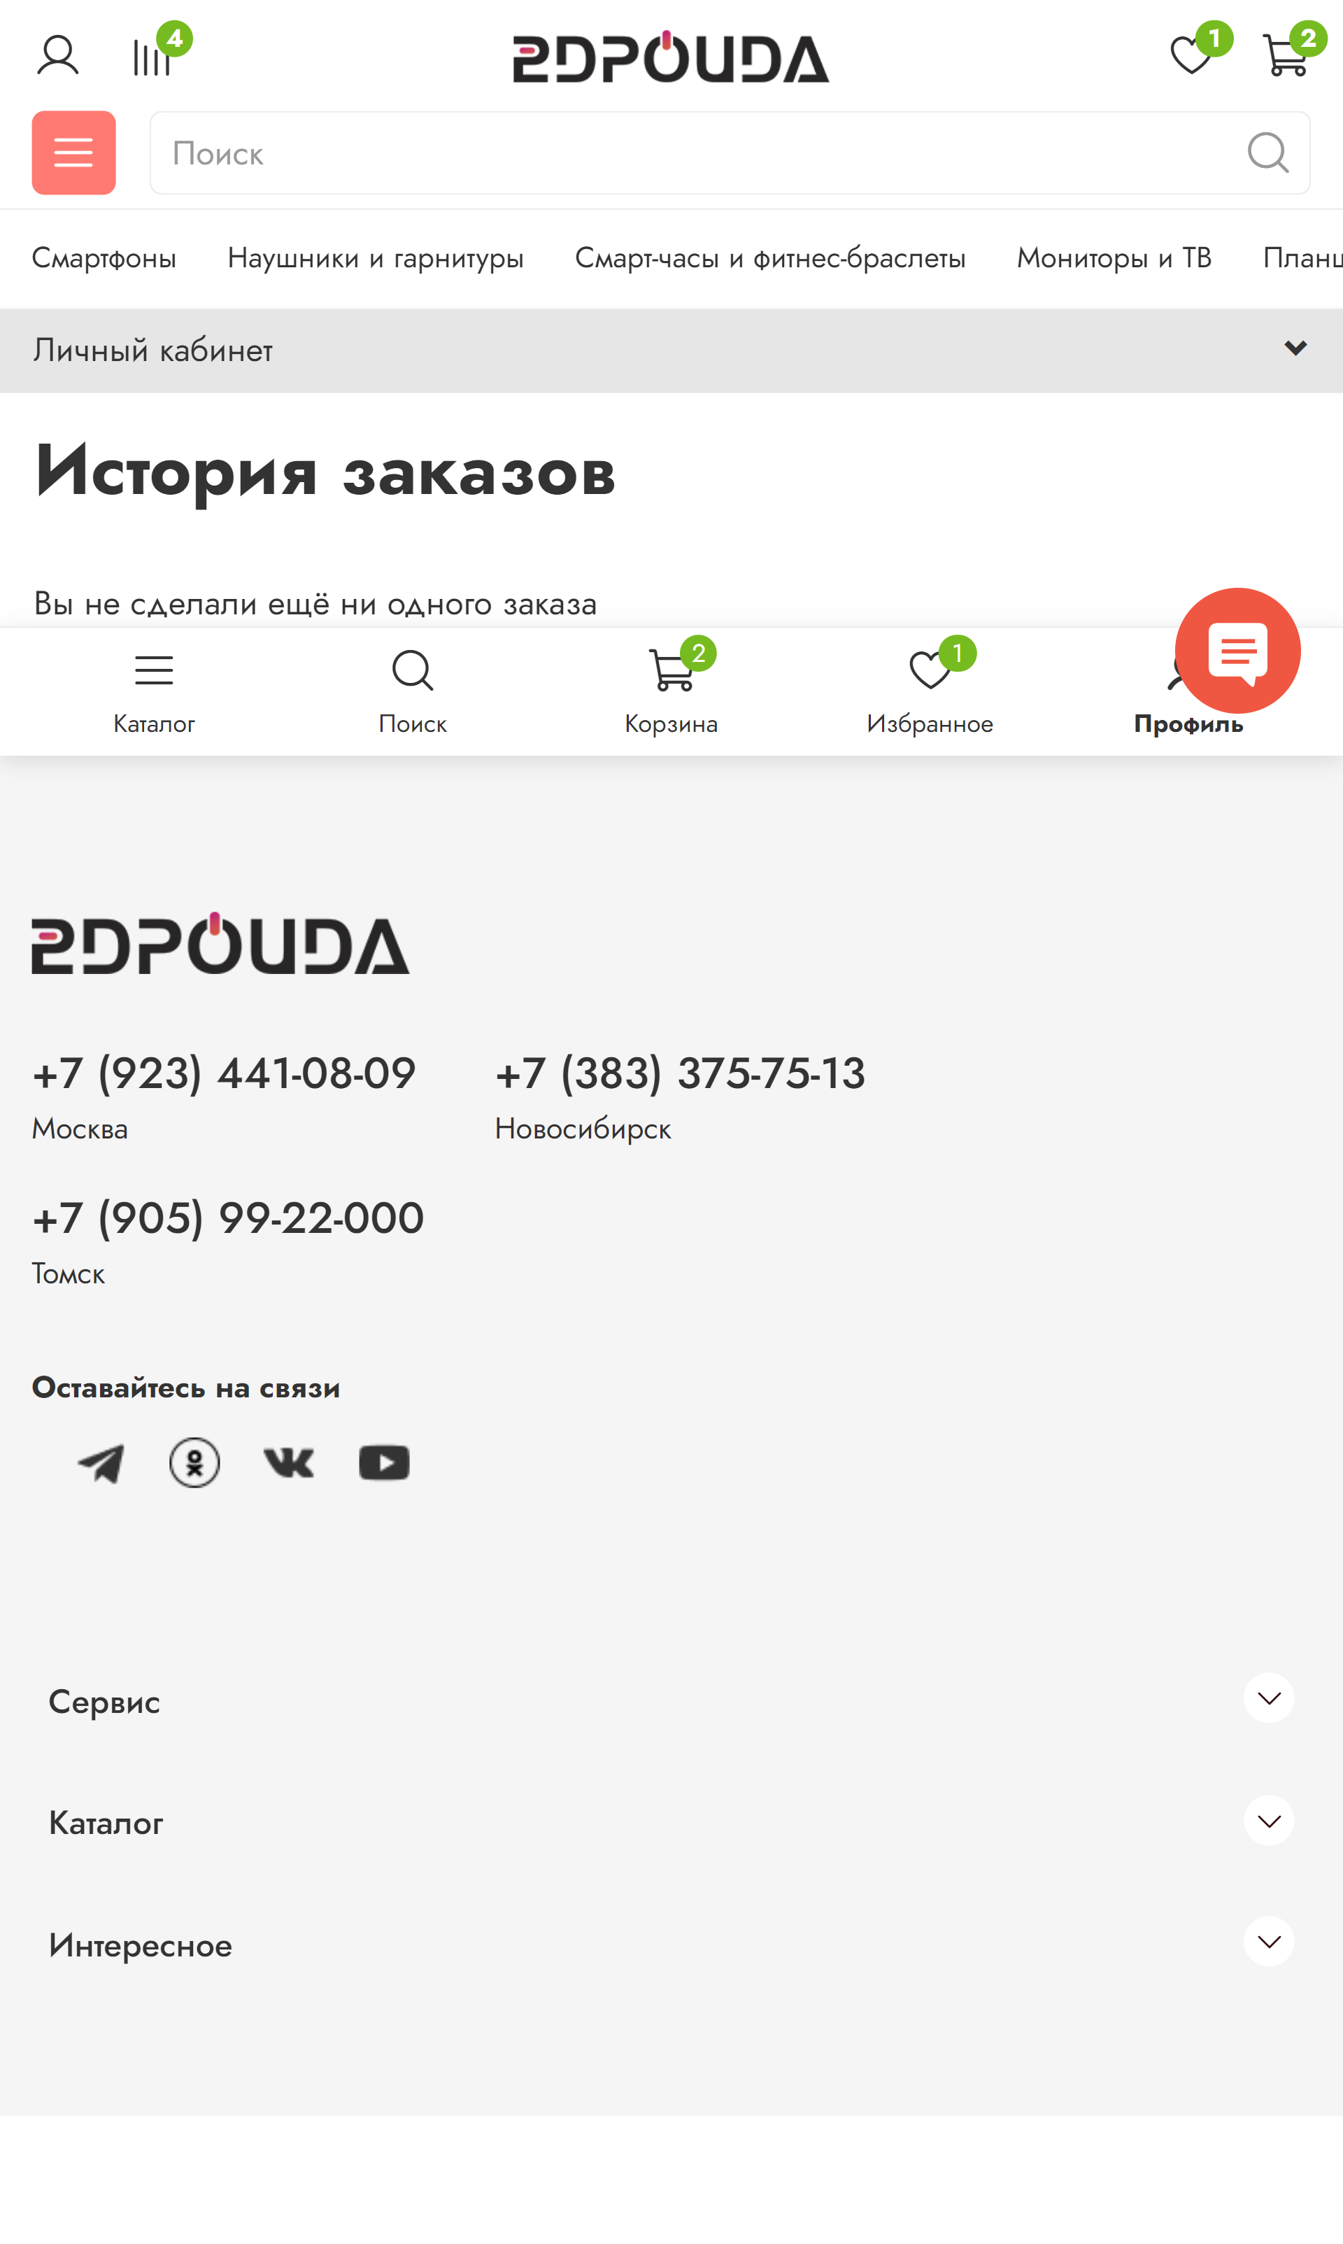

Nexus 5

